**Subject: PRF192 - PFC**

**Workshop 01**

**Name: your_name**

**Student ID: your_student_ID**

**Objectives:**

1. Reviewing for number systems.
2. Exploring memory of a C program.

**Recommendations:**

Part 1: Students do exercises using notebooks.

Part 2: Students develop programs, run them, write down their memory structure to notebooks.

**Part 1: Number systems:**

**Exercise 1 (2 marks): Convert decimal numbers to binary ones.**

| **Decimal** | **4-bit Binary** | **Decimal** | **8-bit Binary** | **Decimal** | **16-bit Binary** |
| --- | --- | --- | --- | --- | --- |
| 9 | **1001** | 7 | **0000 0111** | 255 | **0000 0000 1111 1111** |
| 7 | **0111** | 34 | **0010 0010** | 192 | **0000 0000 1100 0000** |
| 2 | **0010** | 125 | **0111 1101** | 188 | **0000 0000 1011 1100** |
| 15 | **1111** | 157 | **1001 1101** | 312 | **0000 0001 0011 1000** |
| 12 | **1100** | 162 | **1010 0010** | 517 | **0000 0010 0000 0101** |
| 11 | **1011** | 37 | **0010 0101** | 264 | **0000 0001 0000 1000** |
| 6 | **0110** | 66 | **0100 0010** | 543 | **0000 0010 0001 1111** |
| 5 | **0101** | 77 | **0100 1101** | 819 | **0000 0011 0011 0011** |
| 8 | **1000** | 88 | **0101 1000** | 1027 | **0000 0100 0000 0011** |
| 13 | **1101** | 99 | **0110 0011** | 2055 | **0000 1000 0000 0111** |
| 14 | **1110** | 109 | **0110 1101** | 63 | **0000 0000 0011 1111** |

**Exercise 2 (2 marks): Convert decimal numbers to binary and hexadecimal ones.**

| **Decimal** | **Binary** | **Hexa.** | **Decimal** | **16-bit Binary** | **Hexadecimal** |
| --- | --- | --- | --- | --- | --- |
| **9** | **1001** | **09** | **255** | **0000 0000 1111 1111** | **00FF** |
| **127** | **0111 1111** | **7F** | **192** | **0000 0000 1100 0000** | **00C0** |
| **125** | **0111 1101** | **7D** | **188** | **0000 0000 1011 1100** | **00BC** |
| **157** | **1001 1101** | **9D** | **312** | **0000 0001 0011 1000** | **0138** |
| **162** | **1010 0010** | **A2** | **517** | **0000 0010 0000 0101** | **0205** |
| **37** | **0010 0101** | **25** | **264** | **0000 0001 0000 1000** | **0108** |
| **66** | **0100 0010** | **42** | **543** | **0000 0010 0001 1111** | **021F** |
| **77** | **0100 1101** | **4D** | **819** | **0000 0011 0011 0011** | **0333** |
| **88** | **0101 1000** | **58** | **1027** | **0000 0100 0000 0011** | **0403** |
| **99** | **0110 0011** | **63** | **2055** | **0000 1000 0000 0111** | **0807** |
| **109** | **0110 1101** | **6D** | **63** | **0000 0000 0011 1111** | **003F** |

**Exercise 3 (2 marks): Compute.**

(b: binary, q: octal, h: hexadecimal, d: decimal)

**3 245 q + 247 q = ?q = ?b**

**3 245 q + 247 q = 3 514 q = 0111 0100 1100 b**

**1A7B h + 26FE7 h = ?h = ?b**

**1A7B h + 26FE7 h = 2 8A62 h = 0010 1000 1010 0110 0010 b**

**1101101101 b - 10110111 b = ?b**

**1101101101 b - 10110111 b = 0010 1011 0110 b**

**3654 q - 337 q = ?q = ?b**

**3654 q - 337 q = 3 315 q = 0110 1100 1101 b**

**3AB7 h - 1FA h = ?h = ?b**

**3AB7 h - 1FA h = 38BD h = 0011 1000 1011 1101 b**

**36A h - 576 q = ?h = ?b**

**576 q = 17E h**

**36A h - 576 q = 36A h - 17E h = 1EC h = 0001 1110 1100 b**

**64AE h - 1001101 b = ?q**

**1001101 b = 4D h**

**64AE h - 1001101 b = 64AE h - 4D h = 6461 h = 62 141 q**

**1 0110 1111 b**

**+ 1 0011 1011 b**

**1 1011 0001 b**

**1 1000 1101 b**

**= 0101 1110 1000 b**

**1011010 b * 1011 b**

**01011010 b**

**x 1011 b**

**01011010 b**

**01011010 b**

**00000000 b**

**01011010 b**

**= 01111011110 b = 0011 1101 1110 b**

**1101000 b + 2AB h + 345 q = ?h = ?q**

**1101000 b = 68 h**

**345 q = E5 h**

**1101000 b + 2AB h + 345 q = 68 h + 2AB h + E5 h = 3F8 h**

**3F8 h = 0011 1111 1000 b**

**3AF h / 1C h = ?b = ?d**

**3AF h = 943 d**

**1C h = 28 d**

**3AF h / 1C h = 943 d / 28 d = 33 d = 0010 0001 b**

**3AC h – 562 q = ?b = ?d**

**3AC h = 940 d**

**562 q = 370 d**

**3AC h – 562 q = 940 d - 370 d = 570 d = 0010 0011 1010 b**

**3FFA h / 327 q = ?b = ?d**

**3FFA h = 16378 d**

**327 q = 215 d**

**3FFA h / 327 q = 16378 d / 215 d = 76 d = 0100 1100 b**

**Exercise 4 (2 marks):**

1. **Show binary formats of 1-byte unsigned numbers: 251, 163, 117.**

**25110 = 1111 11012**

**16310 = 1010 00112**

**11710 = 0111 01012**

1. **Show binary formats of 2-byte unsigned numbers: 551, 160, 443.**

**55110 = 0000 0010 0010 01112**

**16010 = 0000 0000 1010 00002**

**44310 = 0000 0001 1011 10112**

1. **Show binary formats of 1-byte signed numbers: -51 , -163, -117, 320.**

**-5110 = 1100 11012**

**-16310 = 0101 11012**

**-11710 = 1000 10112**

**32010 = overflow 8-bit, cannot storaged by binary formats of 1-byte.**

1. **Show the decimal values of 1-byte unsigned representations: 01100011 b , 10001111 b , 11001010 b , 01001100 b**

**0110 0011 b = 99 d**

**1000 1111 b = 143 d**

**1100 1010 b = 202 d**

**0100 1100 b = 76 d**

**Part 2: Explore memory structure of programs:**

**Sample**

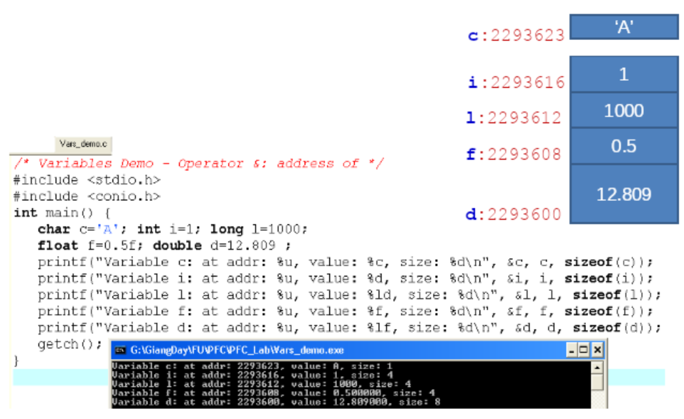

**Complete the code of following program then draw it’s memory structure. (2 marks)**

